**DAILY ONLINE ACTIVITIES SUMMARY**

|  |  |  |  |  |  |  |  |  |
| --- | --- | --- | --- | --- | --- | --- | --- | --- |
| **Date:** | **08/06/2020** | | | | | **Name:** | **Pratibha Shetti** | |
| **Sem & Sec** | **IV sem & B section** | | | | | **USN:** | **4AL18CS062** | |
| **Online Test Summary** | | | | | | | | |
| **Subject** | | **Complex Analysis, Probability and Statistical Methods** | | | | | | |
| **Max. Marks** | | **30** | | **Score** | | | **20** | |
| **Certification Course Summary** | | | | | | | | |
| **Course** | **E-Commerce** | | | | | | | |
| **Certificate Provider** | | | **IIDE** | | **Duration** | | | **2 hours** |
| **Coding Challenges** | | | | | | | | |
| **Problem Statement1:** | | | | | | | | |
| **Status: Executed** | | | | | | | | |
| **Uploaded the report in Github** | | | | | **YES** | | | |
| **If yes Repository name** | | | | | <https://github.com/pratibhashetty-123/Lockdown-coding-java>  <https://github.com/pratibhashetty-123/Lockdown-coding-for-C> | | | |
| **Uploaded the report in slack** | | | | | **YES** | | | |

Online Test Summary: 18MAT41 test was scheduled from 9:30am t0 10:10am .The portion for the IA was 2nd module there were 15 questions and the time assigned was 40 minutes the questions were mcq type.

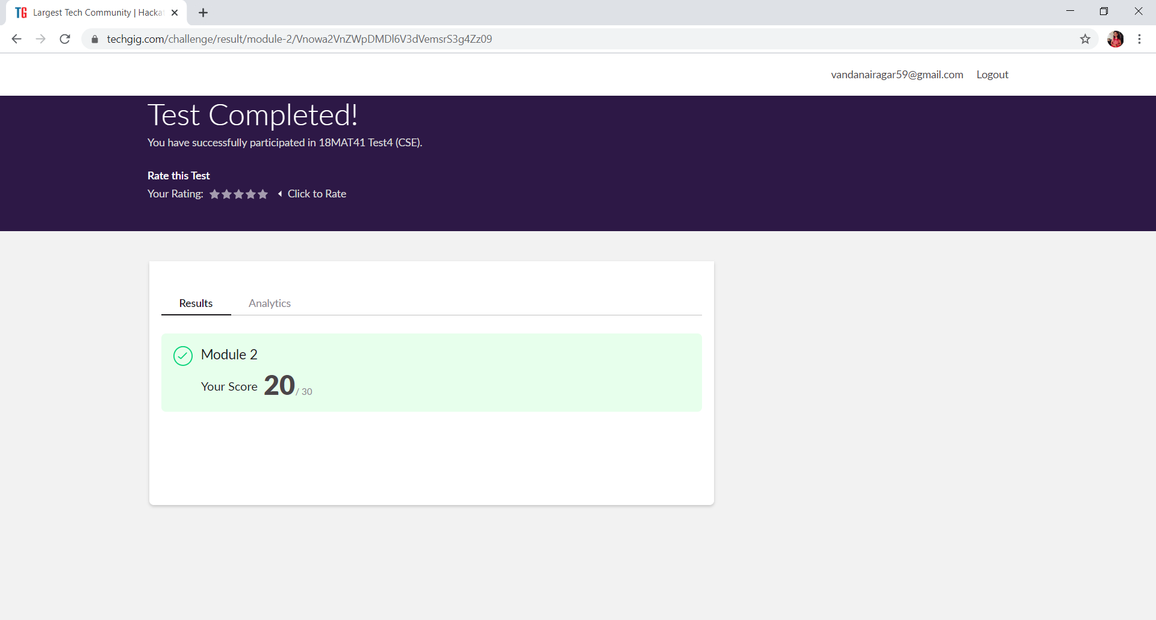

This is the snap shot of the test completed and the marks obtained.

Online Certification Course Summary: Today I have attend the

E-commerce 101 section at 11oclok where I have learnt about how to set up our online store .

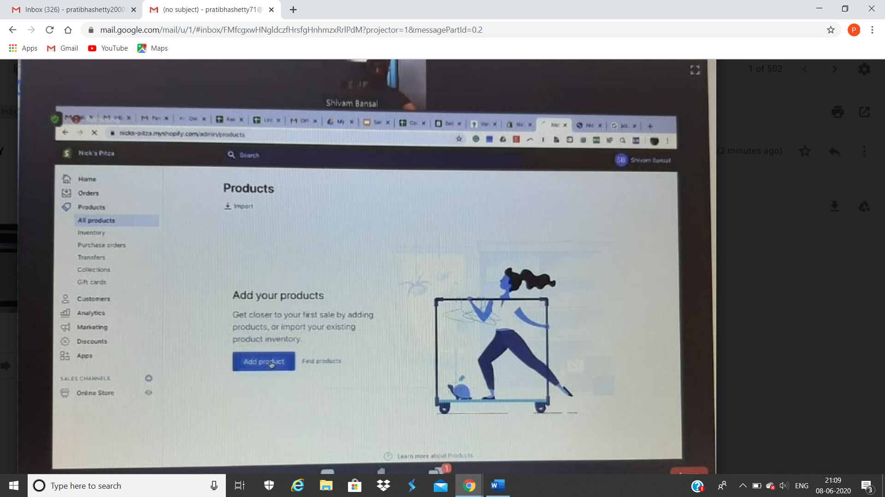

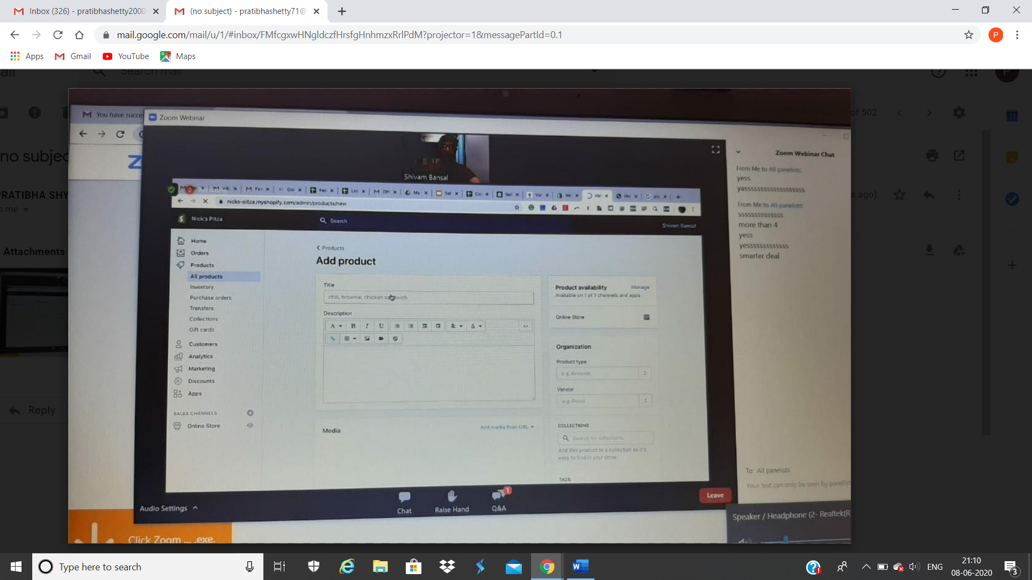

These are the snap shots of today’s sessions.

Online Coding Summary: **Today I had received one program from prof. Shilpa CSE Dept. and other from prof. Venkatesh CSE Dept. The program is mentioned above in the coding challenges(pg.01). I have also uploaded it to my Github repository.**

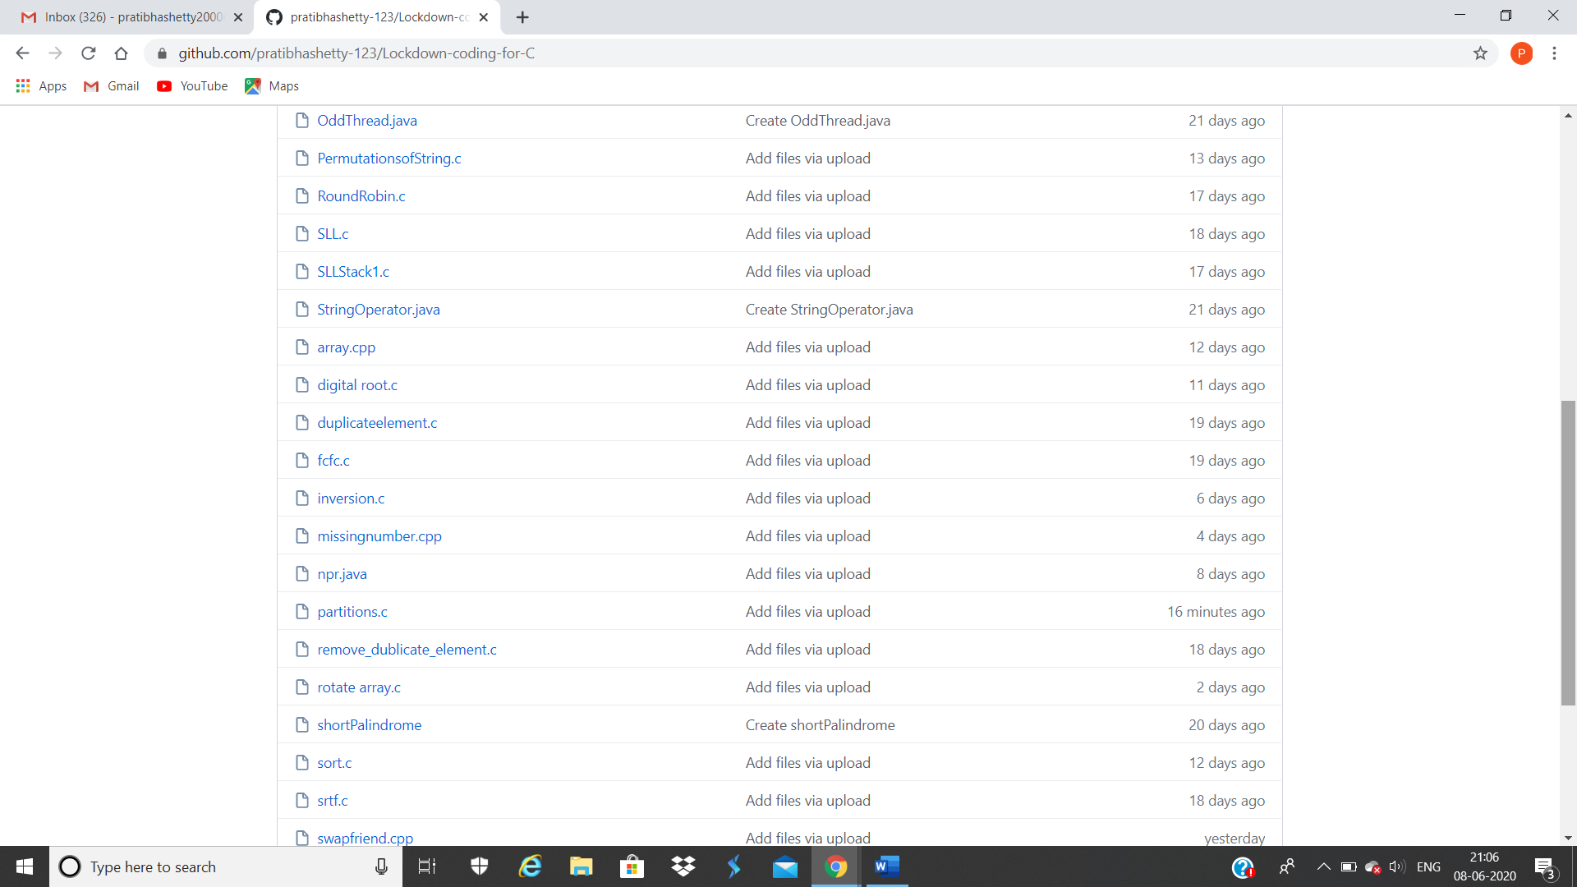

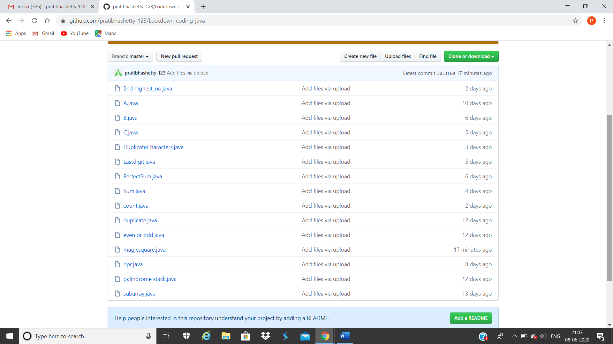**This is the snap shot of my Github repository** were I have uploaded the code. File name is partitions.c and magicsquare.java